**LAPORAN PRAKTIKUM**

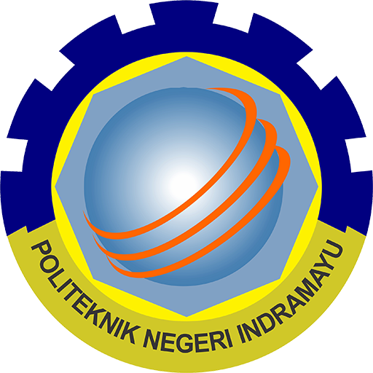

|  |  |  |
| --- | --- | --- |
| **NIM** | **:** | 2003071 |
| **Nama** | **:** | Hakim Asrori |
| **Kelas** | **:** | D3TI.2C |
| **Mata Kuliah** | **:** | **Pemrograman Perangkat Bergerak (TIU3403)** |
| **Praktikum ke / Judul** | **:** | 7 / FRAMEWORK FLUTTER LANJUT |
| **Tanggal Praktikum** | **:** | 30 Mei 2022 |
| **Dosen Pengampu** | **:** | Fachrul Pralienka Bani Muhamad, S.ST., M.Kom |

**PROGRAM STUDI D3 TEKNIK INFORMATIKA**

**JURUSAN TEKNIK INFORMATIKA**

**POLITEKNIK NEGERI INDRAMAYU**

**2022**

1. **Tujuan Praktikum**

**Tujuan Umum**

Mahasiswa dapat ….

**Tujuan Khusus**

Mahasiswa mampu:

1. …
2. …
3. **Rangkuman Teori Singkat**
4. Kode Program Main

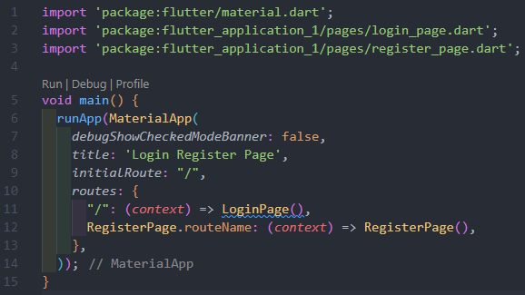

1. Kode Program Login

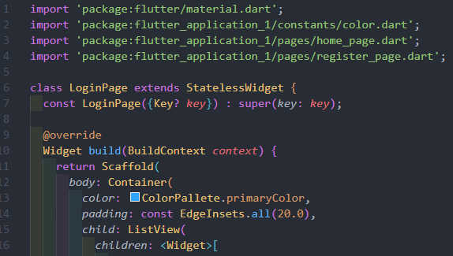

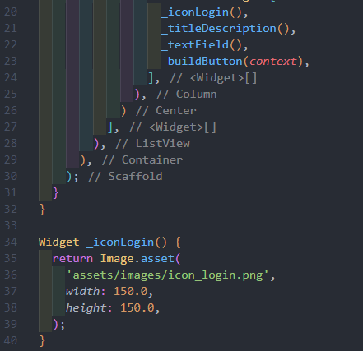

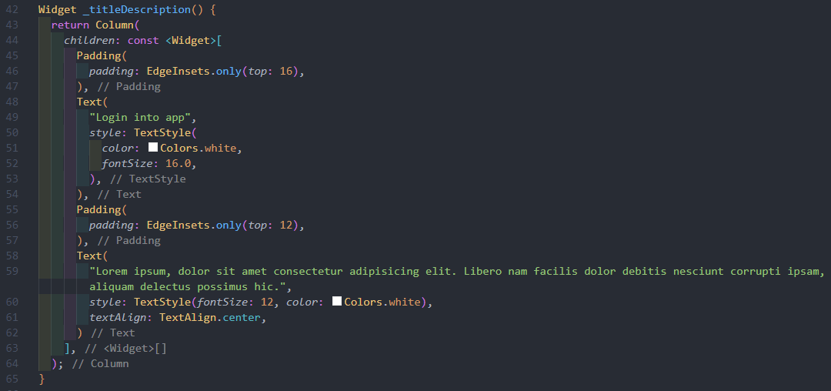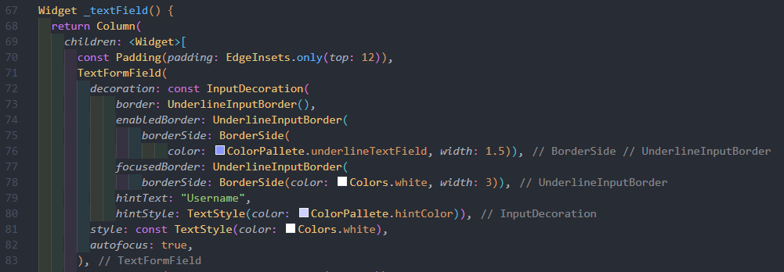

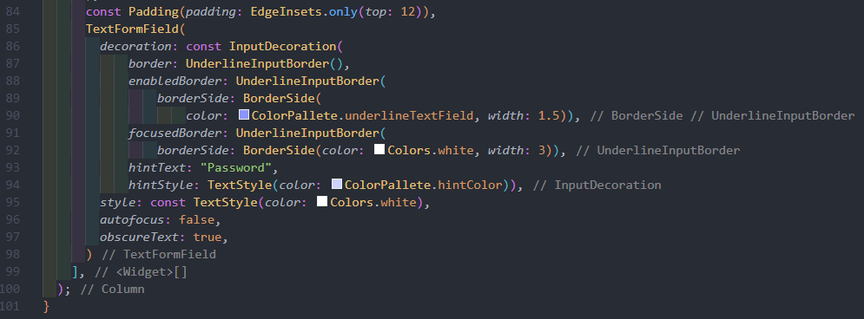

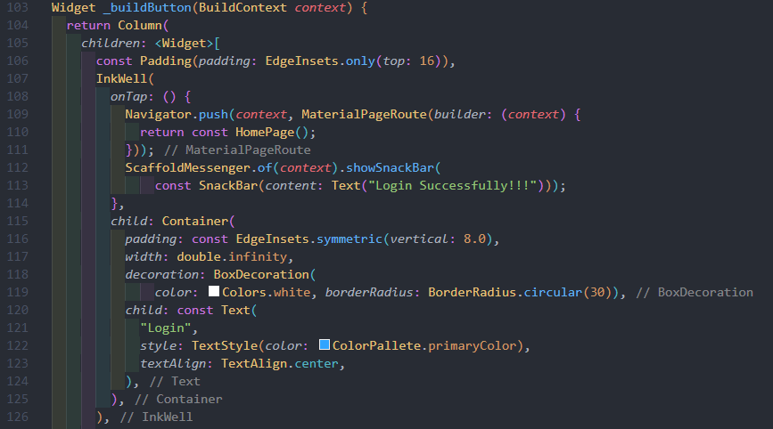

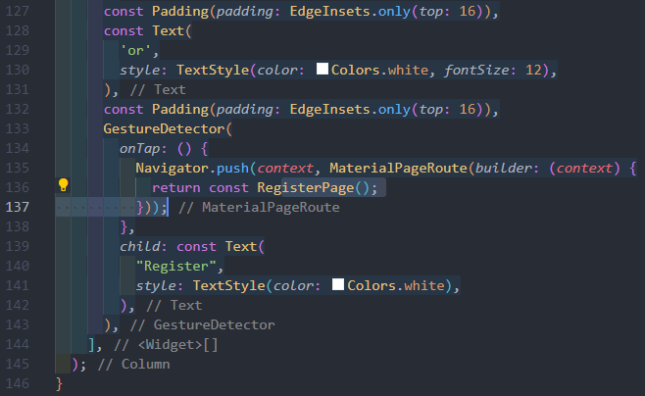

Hasil Kode Program Login

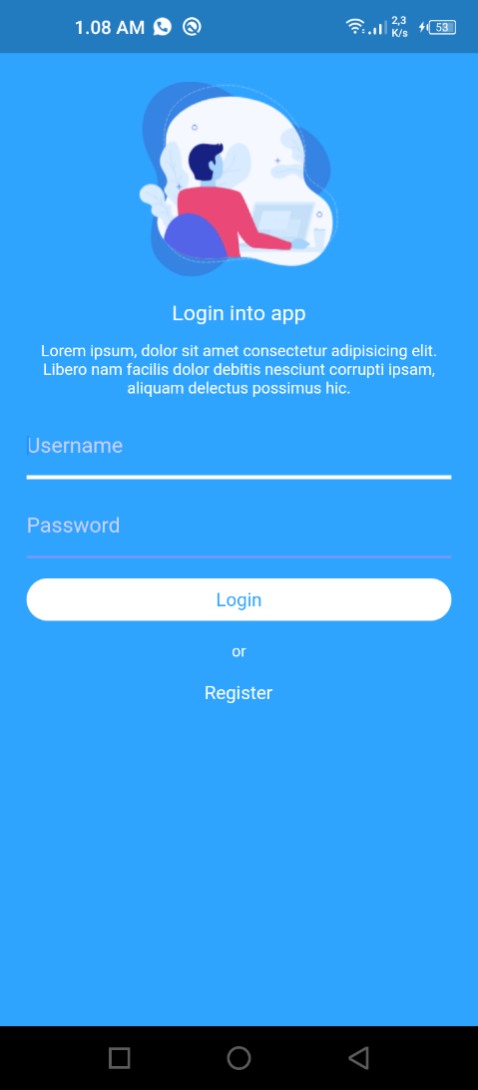

1. Kode Program Register

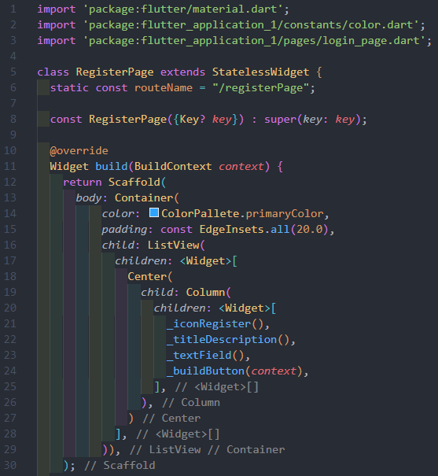

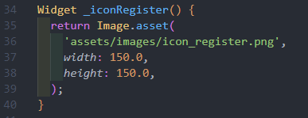

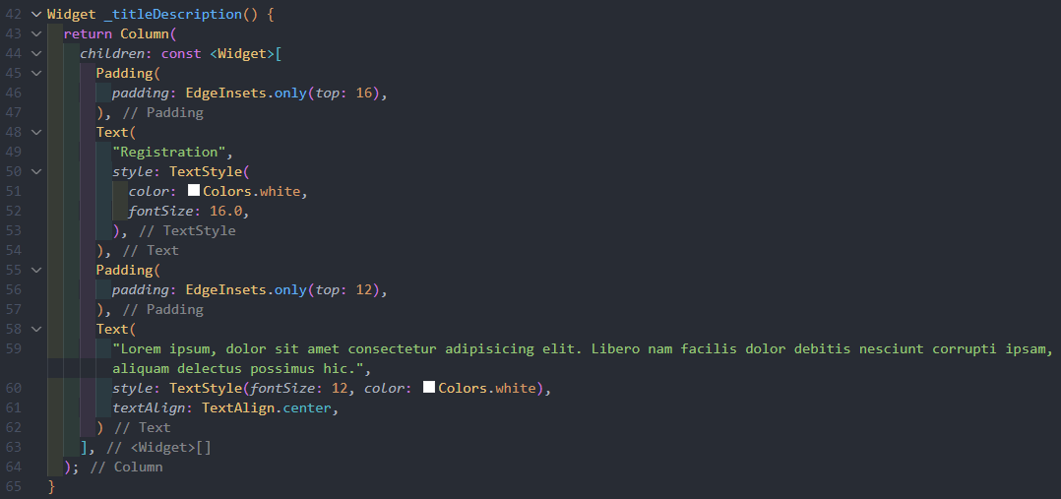

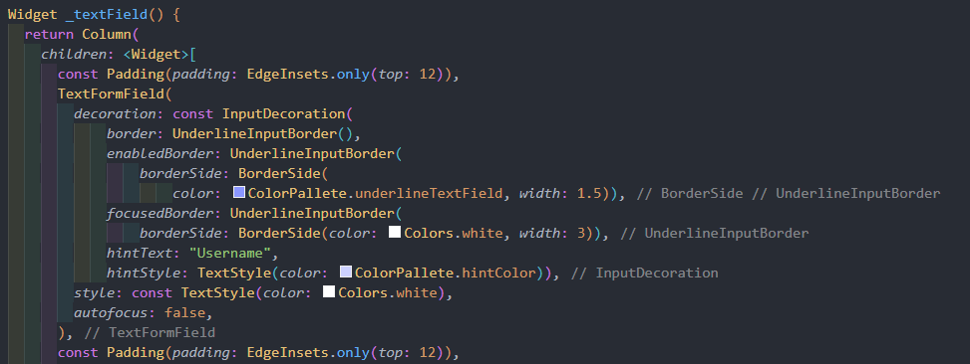

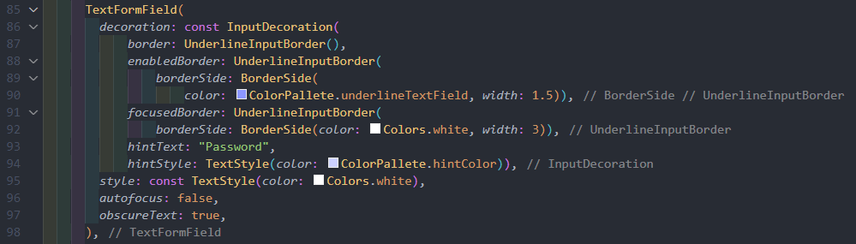

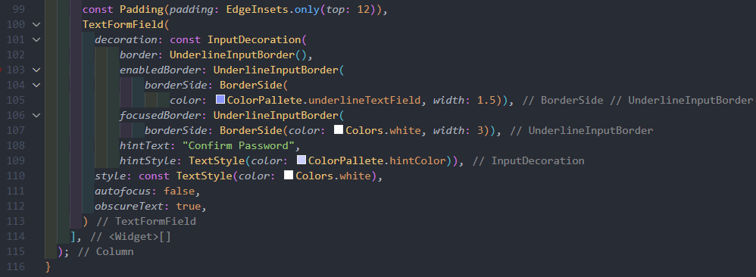

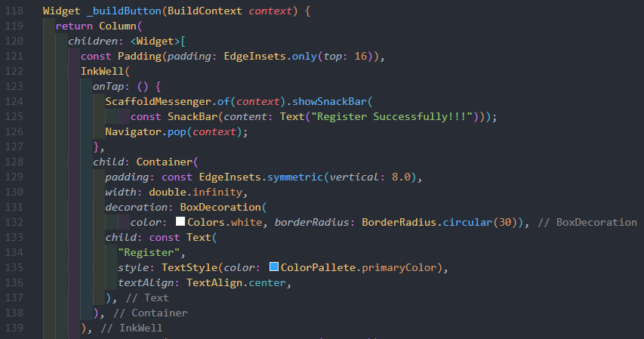

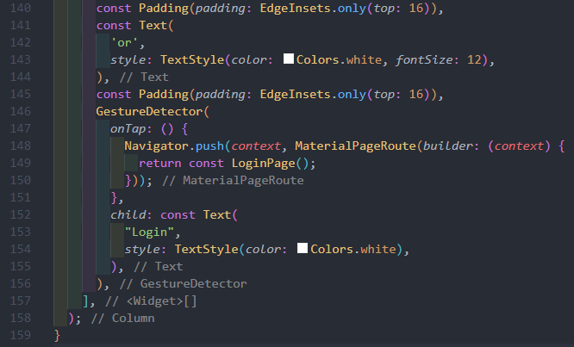

Hasil Kode Program Register

1. Kode Program Home

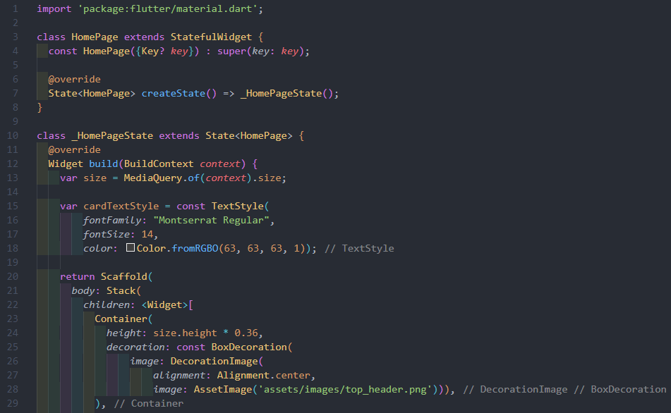

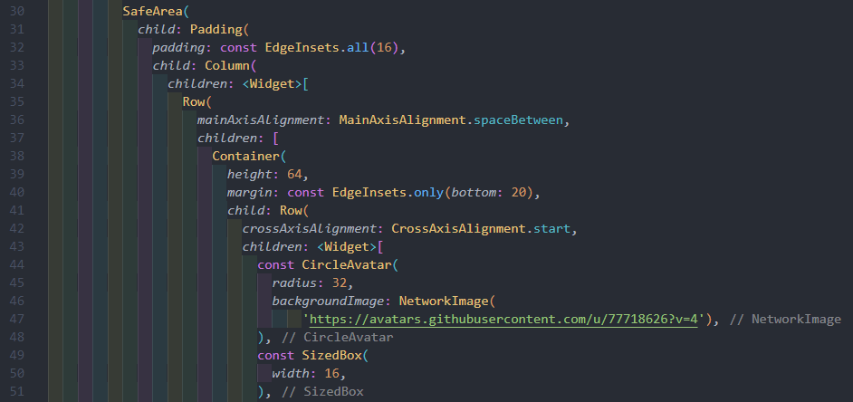

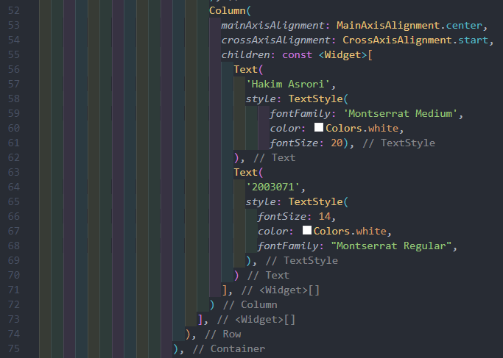

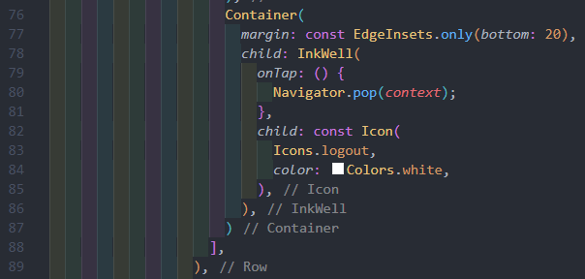

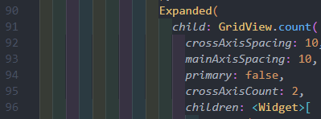

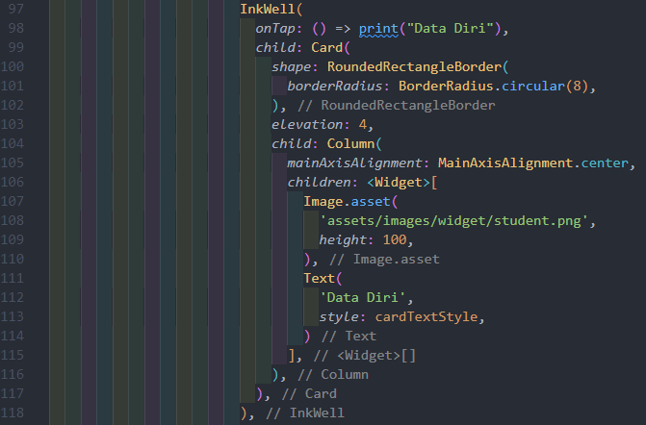

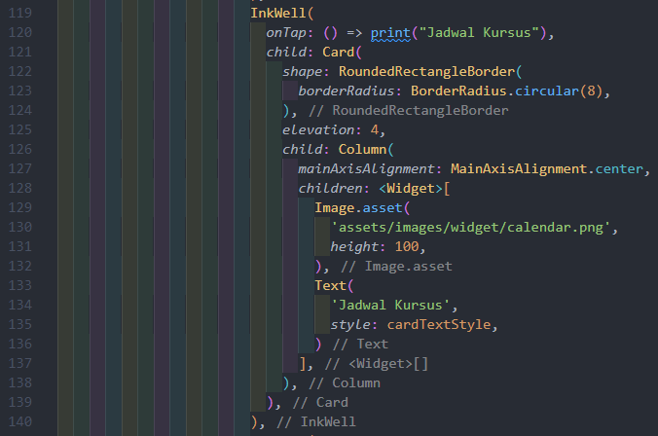

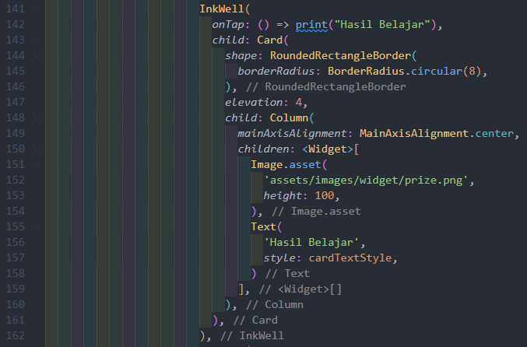

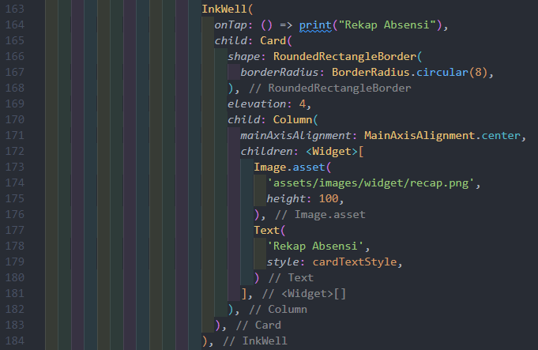

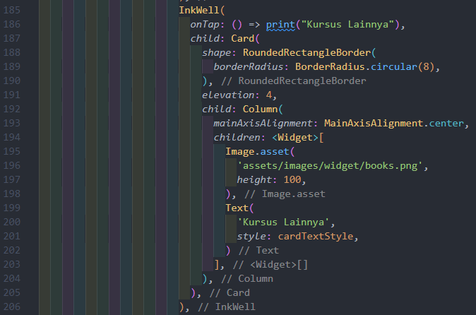

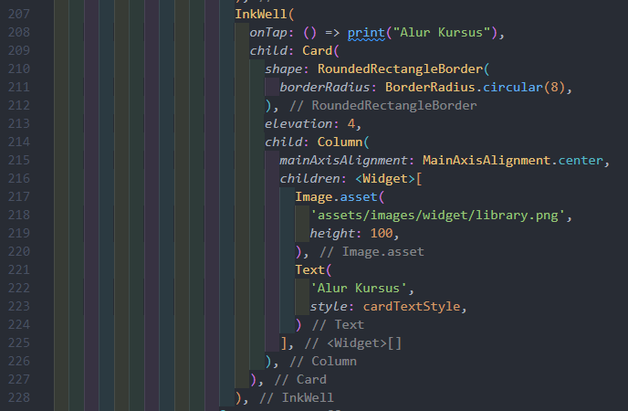

Hasil Kode Program Home

1. Kode Program Menu Logout

1. **Langkah dan Hasil Pelaksanaan Praktikum**
2. **Langkah dan Hasil Latihan**
3. **Hasil dan Penjelasan Tugas**
4. **Kesimpulan**
5. **Referensi**

* Alberto Miola. “Flutter Complete Reference Create Beautiful, Fast and Native Apps for Any Device”. Independently Published. 2020.
* Simone Alessandria, Brian Kayfirz. “Flutter Cookbook: Over 100 proven techniques and solutions for app development with Flutter 2.2 and Dart”. Packt Publishing. Birmingham - Mumbai. 2021.
* Dieter Meiller. “Modern App Development with Dart and Flutter 2: A Comprehensive Introduction to Flutter”. Walter de Gruyter GmbH. Berlin - Boston. 2021.
* Priyanka Tyagi. “Pragmatic Flutter: Building Cross-Platform Mobile Apps for Android, iOS, Web & Desktop”. CRC Press Taylor & Francis Group, LLC. London - New York. 2022.